Data Cleaning, Analysis & Visualization with Excel

Project Objective:
The goal of this project is to clean and transform raw product data to ensure accuracy, consistency, and usability. This involves handling missing values, correcting inconsistent text formats, fixing typos, removing duplicates, splitting and merging columns, applying proper number formatting, and using conditional formatting.

Dataset Description:
- Data entry, import, and basic organization using tables
- Data cleaning: find/remove duplicates, handle missing/inconsistent data, correct formatting errors, and validate data
- Remove the column that contains irrelevant data if it exists
- Application of Excel formulas for calculations, summaries, and logical/text operations
- Use XLOOKUP/VLOOKUP functions to combine the tables.
- Use Pivot Tables for advanced summarization
- Descriptive statistics (mean, median, mode, standard deviation, etc.)
- Data visualization to create three chart types, build an interactive dashboard, and use basic PivotCharts

Column Description

Column Name | Description
Customer ID | Customer identification
Name | Name of the customers
Age | Age of the customers
Gender | Type of the gender
City | Cities of the customers
State | States of the customers
Country | Country of the customers
Loyalty Level | Loyalty levels of the customers
Product ID | Product identification
Product Name | Name of the products
Category | Categories of the products
Brand | Brand names of the products
Cost | Cost of the products
Stock | Stock levels of the products
Store ID | Store identification
Store Name | Name of the stores
Region | Name of the regions
Store Type | Type of stores
Sales ID | Sales identification
Order Date | Sales order date
Quantity | Sales quantity
Unit Price | Unit price of the quantity
Discount | Discount level
Payment Type | Method wise payment
Total Amount | Total price of quantity

Data cleaning & transformation:
The following steps all are used for data cleaning and transformation
- Use Clean,Trim and Proper function to modify the Name Column.
- Use Find and Replace method to modify United States of America into USA.
- In Loyalty Level I can found some missing values use IF(ISBLANK([@[Loyalty_Level]]),"Unknown",[@[Loyalty_Level]]) Formula to fill the missing values in all the missing rows.
- Use find and replace method to modify the product id’s
- No duplicate values are found.
- In Brand column found some inconsistent data, I can use Clean,Trim and Proper function to modify all the inconsistent datas.
- Use IF(ISBLANK(G6),AVERAGE(G6:G105),G6) formula to fill missing values in the stock column
- Use IF(ISBLANK(F6),AVERAGE(F6:F105),F6) formula to fill missing values in the cost column
- Use PROPER(TRIM(CLEAN(C2))) function to correct the Store Name column.
- Order date has been modified to proper date format.
- Quantity column found some missing values, use IF(ISBLANK(F2),AVERAGE(F2:F2001),F2) function to fill the missing values
- In unit price column found some missing values, use IF(ISBLANK(G2),AVERAGE(G2:G2001),G2) function to fill the missing values
- Discount column find some some missing values, use IF(ISBLANK(H2),"0",H2) method to fill all the missing values
- We have identified some problem in the total amount use (G2-H2)*F2 formula to calculate the total price.
- All the Irrelevant data columns has been removed.

Formula used:
- IF(ISBLANK([@[Loyalty_Level]]),"Unknown",[@[Loyalty_Level]])
- Clean,Trim and Proper
- IF(ISBLANK(G6),AVERAGE(G6:G105),G6)
- IF(ISBLANK(F6),AVERAGE(F6:F105),F6)
- PROPER(TRIM(CLEAN(C2)))
- IF(ISBLANK(F2),AVERAGE(F2:F2001),F2)
- IF(ISBLANK(G2),AVERAGE(G2:G2001),G2
- IF(ISBLANK(H2),"0",H2)
- (G2-H2)*F2
- XLOOKUP(Table4[@[Customer_ID]],Table1[Customer_ID],Table1[Name],"Not Found",0)
- SUM([Cost])
- AVERAGE(H2:H2001)
- escriptive statistics Analysis ToolPak used for Unit Price in Sales Fact and Cost in Product Dim
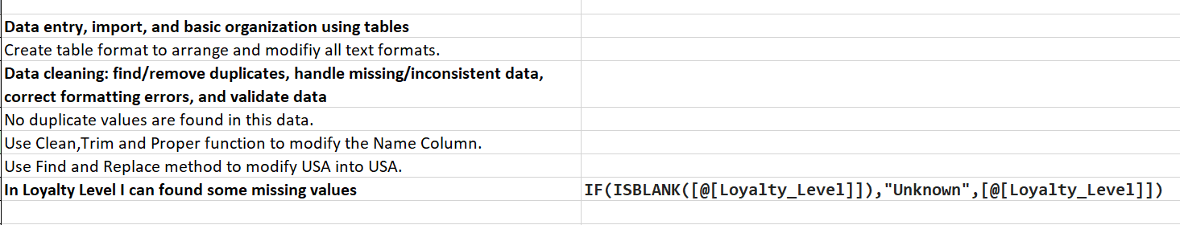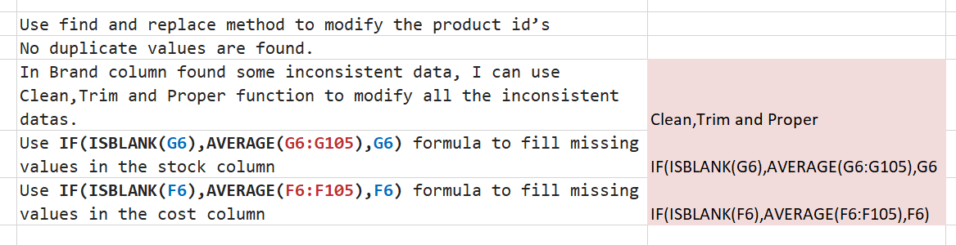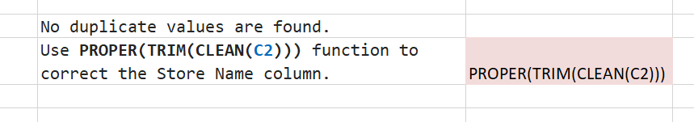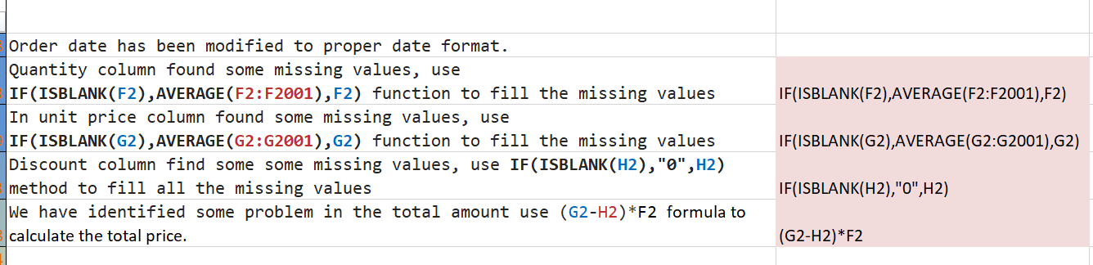

Visualization and Insights Arrived with screenshot of visualization
Report/Dashboard screenshot:

- Descriptive analysis:
Use pivot table to analyse total sales, Average price and total cost.
- Insight:
Highest revenue generator or contributor is Electronics and Sports categories

- Diagnostic Analysis:
Use pivot table to analyse the which gender and age wise sales
- Insight:
25 to 35 years both male and female spend more money to buy a electronic items
- Predictive Analysis:
Predictive analysis is based on line based price
The highest value is upper line
The lowest value is Lower line
- Insight:
Based on this analysis the prices shall remain Rs.200 to 300 for next year
- Prescriptive Analysis:
We can suggest more marketing strategies and discount strategies for low performing products
- Insight:
To boost overall sales we can do more promotions for beauty products

Dashboard Image:

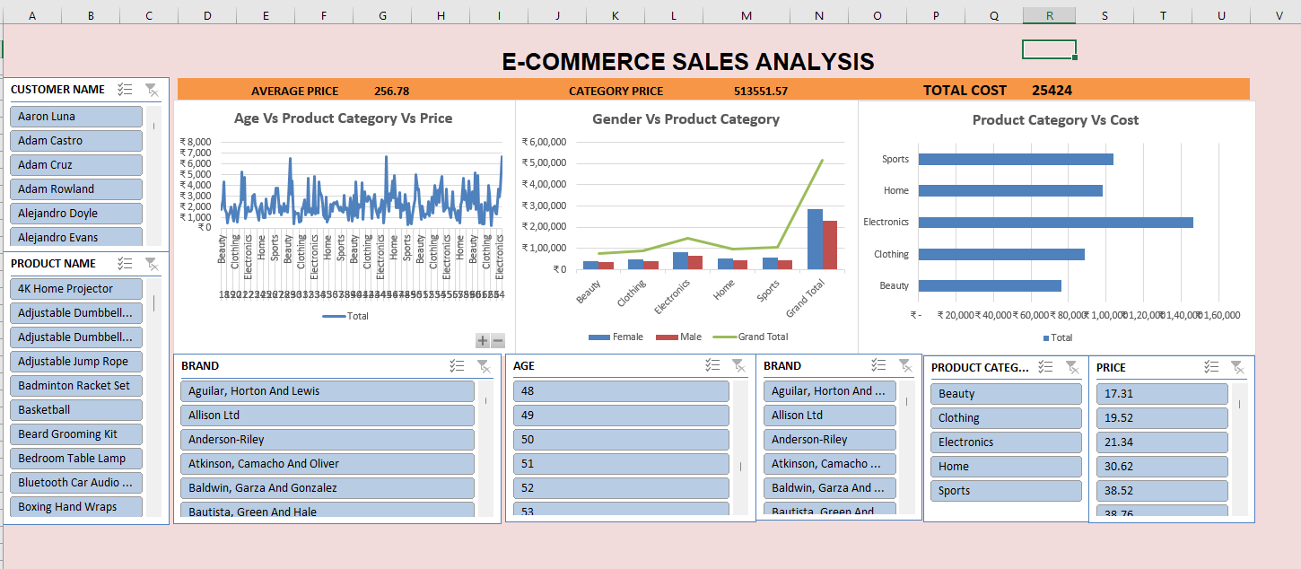

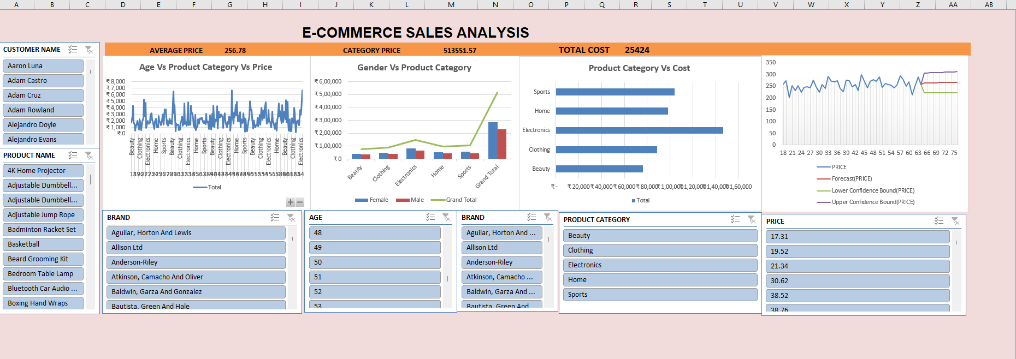
Conclusion:
The final conclusions of the e-commerce sales analysis have a strong performance in electronic and sports categories with the age group of 25 to 35 and Forecast analysis clearly shows the prices ranges shall remains the Rs.200 to 300 for the upcoming years and also we Suggest more discounts to be given by non-performing products to increase the overall sales more business related promotional activities are conducted in tier-2 cities. These actions all give more performance for business.

